Homework 1

Review:
R1: What is the difference between a host and an end system? List several different types of end systems. Is a Web server an end system?
There is no difference between host and end systems. On the internet, all devices are called hosts or end systems. So, hosts and end systems are used interchangeably. Types of end systems would include PC’s, work stations, email servers, PDAs, etc. Yes a web server is an end system.
R23: What are the five layers in the Internet protocol stack? What are the principal responsibilities of each of these layers?

- From top to bottom it is:
  - The Application Layer
    - Where network applications and their application-layer protocols reside. The Internet’s application layer includes many protocols, such as the HTTP, SMTP, and FPT. An application-layer protocol is distributed over multiple end systems, with the application in one end system using the protocol to exchange packets of information with the application in another end system. Packet of information is called Message.
  - The Transport Layer
    - Transports application-layer messages between application endpoints. Packet of information is called Segment.
  - The Network Layer
    - Responsible for moving network-layer packets known as datagrams from one host to another.
  - The Link/Data link Layer
    - Routes a datagram through a series of routers between the source and destination. To move a packet from one node (host or router) to the next node in the route, the network layer relies on the services of the link layer.
  - The Physical Layer
    - Move the individual bits within the frame from one node to the next.

R28: Suppose Alice and Bob are sending packets to each other over a computer network. Suppose Trudy positions herself in the network so that she can capture all the packets sent by Alice and send whatever she wants to Bob; she can also capture all the packets sent by Bob and send whatever she wants to Alice. List some of the malicious things Trudy can do from this position.
Trudy can return bogus replies and make either Alice or Bob’s server accept bogus records into its cache. Also she can pretend to be either Bob or Alice and easily change information sent from one to the other. Finally she can also drop packets being sent even if they are encrypted.

Problems:

P1: Design and describe an application-level protocol to be used between an automatic teller machine and a bank’s centralized computer (BCC).
- User’s card and password are entered and verified
- The Account balance(BCC) are queried
- Money is disbursed to user
- Handle all-too-common case in which there is not enough money in the account to cover the withdrawal
Step 1: Specification
Specify the protocol by listing the messages exchanged and the action taken by the ATM or the BCC on the transmission and receipt of the message.
Possible messages to be sent from ATM to server
Message Name | Purpose
HELLO<user_id> | Let BCC know there is the card user ID in ATM
PASSWORD<pass_word> | User enters PIN
BALANCE | User requests balance
WITHDRAWAL<amt> | User asks for withdrawal
BYE | All done
Possible messages to be sent from server to ATM
Message name | Purpose
PASSWORD | Ask user for PIN
OK | Previous request is ok’ed
ERROR | Previous request has error
AMOUNT<amt> | Sent in response to BALANCE request
BYE | All done, return to welcome screen

Step 2: Operation Example
Sketch the operation of the protocol for the case of simple withdrawal with no errors, using a diagram.
Step 3: Underlying end-to-end transport service
Explicitly state the assumptions made by the protocol about the underlying end=to-end transport service.
    - Connection-oriented : secure “connection” required between client and server
    - Reliable transport: data cannot be loss or received in the wrong order
    - Flow control: Total amount of data transferred is small
    - Congestion control: application cannot congest the network
    - Timing: not time sensitive.
    - Minimum bandwidth guarantees: messages are too few and small
P4: Figure 1.13
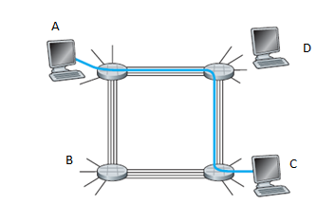
- What is the maximum number of simultaneous connections that can be in progress at any one time in this network?
16 simultaneous connections can be in progress at any one time.
- Suppose that all connections are between switches A and C. What is the maximum number of simultaneous connections that can be in progress?
- Simultaneous connections can be in progress between switches A and C
- Suppose we want to make four connections between switches A and C, and another four connections between switches B and D. Can we route these calls through the four links to accommodate all eight connections?
Yes we can. 2 connections from A -> B, 2 connections from B -> A, 4 connections from A -> D, 4 connections from B -> C, 2 connections from D - > C, 2 connections from C -> D
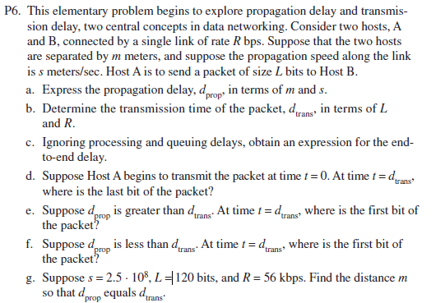
- Propagation delay is caused by the distance over the speed. D_{prop} (seconds) = m/s
- Transmission time is how large the files are over how fast the transmission rate is. D_{trans} (seconds) = L/R
- Ignoring the processing and queuing delays. D_{end-to-end}(seconds) = D_{prop} + D_{trans} = (m/s) + (L/R)
- Since d_{trans} is the time it takes to transmit a whole package. So when t = 0. The whole packet has just left Host A
- If this were to happen we would see the head of the packet would be at the distance s * d_{trans} because the packet will be leaving the host while it’s being transmitted, but only as fast as it can be transmitted.
- The first bit would be at the destination. This is because the time it took for a bit of the packet to get from A to B was less than the time that it took to transmit.
- D_{prop} = d_{trans} so (m/s) / (L/R) => m = s(L/R) => m = (2.5*10⁸m/s)(120bits/56kbps) = 545714.28m
P7: In this problem, we consider sending real-time voice from Host A to Host B over a packet-switched network (VoIP). Host A converts analog voice to a digital 64 kbps bit stream on the fly. Host A then groups the bits into 56-byte packets. There is one link between Hosts A and B; its transmission rate is 2 Mbps and its propagation delay is 10 msec. As soon as Host A gathers a packet, it sends it to Host B. As soon as Host B receives an entire packet, it converts the packet’s bits to an analog signal.

How much time elapses from the time a bit is created (from the original analog signal at Host A) until the bit is decoded (as part of the analog signal at Host B)?
56 *8 (bits/byte)/ (64kbps * 1000ms) = 7ms to encode/decode
+ 56 *8 bytes / 2000000bps(2Mbps) = .224ms
+10ms. Thus 2(7ms) + .224ms + 10ms = 24.224ms
P10:
Consider a packet of length L which begins at end system A and travels over
three links to a destination end system. These three links are connected by
two packet switches. Let di, si, and Ri denote the length, propagation speed,
and the transmission rate of link i, for i = 1, 2, 3. The packet switch delays
each packet by dproc.

Assuming no queuing delays, in terms of di, si, Ri,(i = 1,2,3), and L, what is the total end-to-end delay for the packet?
Length is d_{i} ,prop speed is s_{i} , trans rate is R_{i} , packet-switching delay is d_{proci} and total end-to-end delay is L
L = sum((d_{i} / s_{i}) + (L/R) + d_{proci})
Suppose now the packet is 1,500 bytes, the propagation speed on all three links is 2.5 ·
108 m/s, the transmission rates of all three links are 2 Mbps, the packet switch
processing delay is 3 msec, the length of the first link is 5,000 km, the length
of the second link is 4,000 km, and the length of the last link is 1,000 km. For
these values, what is the end-to-end delay?

11.314ms

P11:
In the above problem, suppose R1 = R2 = R3 = R and dproc = 0. Further suppose
the packet switch does not store-and-forward packets but instead immediately
transmits each bit it receives before waiting for the entire packet to
arrive. What is the end-to-end delay?
Trans rate = R1=R2=R3
Prop delay = 0
Packet = 1500 bytes
Prop speed = 2.5 x 10⁸ m/s
Ans: 46ms
P18:
Perform a Traceroute between source and destination on the same continent
at three different hours of the day.

1PM: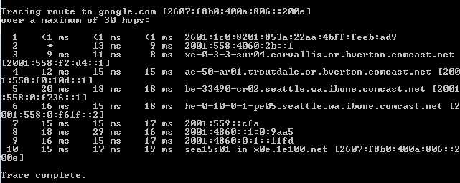
6PM: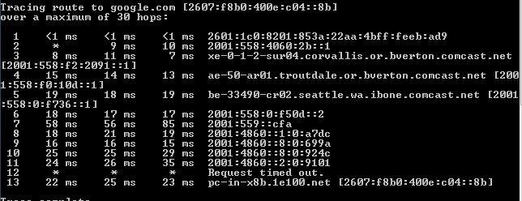
10PM: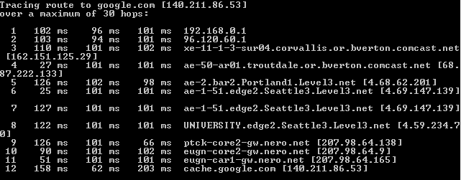
- Find the average and standard deviation of the round-trip delays at each of the three hours.
The average of the round trips at each of the three hours is 15.037ms, 22.212ms, 103ms respectively and the standard deviation is 1.509ms, 2.282ms, 5.019ms respectively.
- Find the number of routers in the path at each of the three hours. Did the paths change during any of the hours?
The number of routers was 10, 12, 13 respectively. The route changed slightly for each but was more or less the same.
- Try to identify the number of ISP networks that the Traceroute packets pass through from source to destination. Routers with similar names and/or similar IP addresses should be considered as part of the same ISP. In your experiments, do the largest delays occur at the peering interfaces between adjacent ISPs?
There were a couple of changes between ISPs. Yes the largest delays occurred at the peering interfaces between adjacent ISPs.
- Repeat the above for a source and destination on different continents.

Traceroutes from www.stella-net.net (France) to www.poly.edu (USA).

The average round-trip delays at each of the three hours are 87.09 ms, 86.35 ms and 86.48 ms, respectively. The standard deviations are 0.53 ms, 0.18 ms, 0.23 ms, respectively. In this, there are 11 routers in the path at each of the three hours.
No, the paths didn’t change during any of the hours.
Traceroute packets passed three ISP networks from source to destination.
Yes, in this experiment the largest delays occurred at peering interfaces between adjacent ISPs

Compare the intra-continent and inter-continent results.
P29:
Suppose there is a 10 Mbps microwave link between a geostationary satellite
and its base station on Earth. Every minute the satellite takes a digital photo and
sends it to the base station. Assume a propagation speed of 2.4 _ 108 meters/sec.
a. What is the propagation delay of the link? 0.15s
b. What is the bandwidth-delay product, R · dprop? 1.5 x 10⁶ bits
c. Let x denote the size of the photo. What is the minimum value of x for the
microwave link to be continuously transmitting? 6 x 10⁸ bits
P30:
Consider the airline travel analogy in our discussion of layering in Section
1.5, and the addition of headers to protocol data units as they flow down the protocol stack. Is there an equivalent notion of header information that is added to passengers and baggage as they move down the airline protocol stack?
In the airline travel, a passenger need to pass through different stages, travel, and pass through reverse order to complete the journey. In a layered structure, the data will need to pass through all stages as it would in the internet protocol.

